**Advance Excel Assignment 1**

1. **What do you mean by cells in an excel sheet?**

Ans. Cells are small rectangular boxes in the worksheet where we enter data. A cell is the intersection of a vertical column and a horizontal row in a worksheet. Vertical columns are numbered with alphabetic values such as A, B, C. Horizontal rows are numbered with numeric values such as 1, 2, 3.

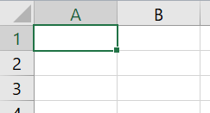

Each cell has its own set of coordinates or position in the worksheet such as A1, A2, B1. In the example above, we are positioned on cell A1 which is the intersection of column A and row 1.

A cell can only store 1 piece of data at a time. You can store data in a cell such as a formula, text value, numeric value, or date value.

1. **How can you restrict someone from copying a cell from your worksheet?**

Ans. To protect your worksheet from getting copied, you need to go into the **Menu bar >Review > Protect sheet > Password**. By entering the password, you can secure your worksheet from getting copied by others.

1. **How to move or copy the worksheet into another workbook?**

Ans. On the Edit menu, click Sheet > Move or Copy Sheet. On the To book menu, click the

workbook that you want to copy the sheet to. Tip: To create a new workbook that

contains the moved sheet, click the new book. In the Before sheet box, click the sheet that

you want to insert the copied sheet before, or click move to end

1. **Which key is used as a shortcut for opening a new window document?**

Ans. Ctrl + N

1. **What are the things that we can notice after opening the Excel interface?**

Ans.

Following things we notice after opening the excel interface

1. Quick access bar
2. Ribbon
3. Name box
4. Formula bar
5. Workspace – Worksheet window
6. Navigation buttons
7. Worksheet tab
8. Status bar

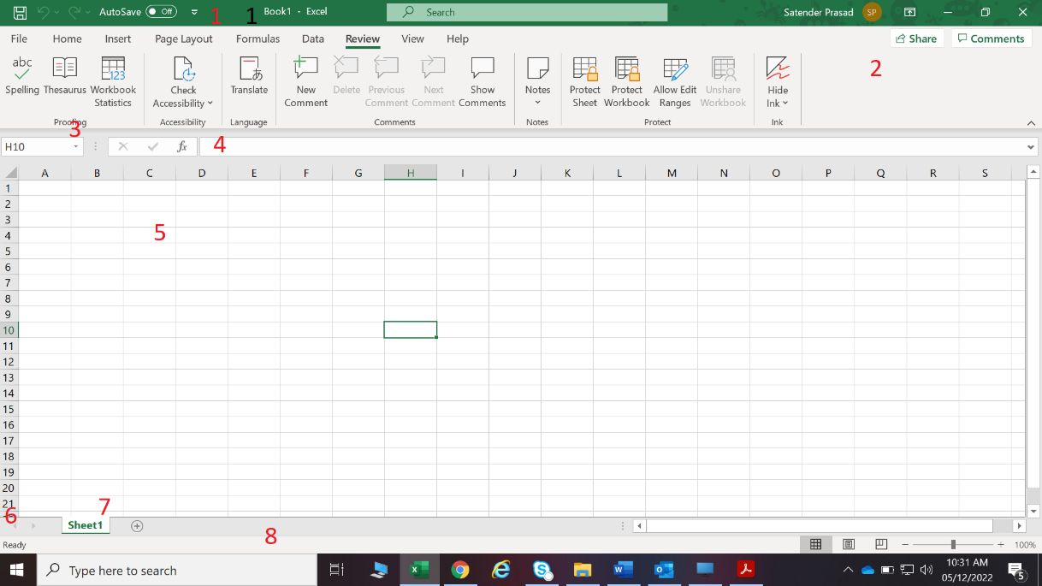

1. **When to use a relative cell reference in excel?**

Ans. Relative cell references are basic cell references that adjust and change when copied or

when using AutoFill. Example: = SUM (B5:B8), as shown below, changes to =SUM (C5:C8)

when copied across to the next cell. Situations arise in which the cell reference must remain

the same when copied or when using AutoFill